
Name:

Set:

Year 10
Geography
Term 2 Examination
2025

 |  |  | General Instructions  - Time – 60 minutes  - Write using black or blue pen  - Draw diagrams using pencil  - Calculators may be used | Total marks – 60  Section 1  20 marks  - Attempt Questions 1 - 16  - Allow about 20 minutes for this section  Section 2  20 marks  - Attempt Questions 17 - 18  - Allow about 20 minutes for this section  Section 3  20 marks  - Attempt Question 19  - Allow about 20 minutes for this section
Note: Any time you have remaining should be spent revising your answers.

DO NOT REMOVE THIS PAPER FROM THE EXAMINATION ROOM

Name:
Set:
Teacher:

SECTION I: SKILLS (20 marks)

Refer to the Stimulus Booklet.
Answer Questions 1-15 using the multiple choice Answer Sheet provided

Refer to Source A on page 1 of the Stimulus Booklet to answer Question 1.
- What was the per capita apparent consumption of fish in 1974?
- 20 million tonnes
- 40 million tonnes
- 60 million tonnes
- 80 million tonnes

Refer to Source B on page 1 of the Stimulus Booklet to answer Question 2.
- What is the wind direction at Point X?
- SE
- NE
- SW
- NW

Refer to Source C on page 2 of the Stimulus Booklet to answer Questions 3 to 12.
- Approximately how long would it take to fly from Tokyo to Aogashima Island in a helicopter travelling at an average speed of 220 km/hour?
- 45 minutes
- 1 hour and 20 minutes
- 1 hour and 45 minutes
- 2 hours and 20 minutes

- What is the direction of Point H from Point C?
- NE
- SSE
- SSW
- SW

- What is the straight-line distance from Point F to Point D ?
- 600 metres
- 800 metres
- 1.2 kilometres
- 1.6 kilometres

- What is the aspect of the slope at the end of the minor road in AR 5190?
- east
- west
- southwest
- northeast

- What is the bearing of Point B from Point D?
- 50°
- 70°
- 230°
- 250°

- What is the density of buildings in AR 5089?
- 3 buildings per square kilometre
- 6 buildings per square kilometre
- 9 buildings per square kilometre
- 12 buildings per square kilometre

- What is the approximate elevation at Point B?
- 180 metres
- 150 metres
- 110 metres
- 80 metres

- What is the approximate area of Aogashima Island?
- 4 square kilometres
- 6.2 square kilometres
- 8 square kilometres
- 12.3 square kilometres

- Calculate the gradient between the spot height in AR 5190 and Point D
- 1 in 2
- 1 in 4
- 1 in 6
- 1 in 8

- Which of the following is visible from the trig station in AR 4990?
- Point G
- Point D
- Point C
- Point B

Refer to Source C on page 2 and Source E on page 3 of the Stimulus booklet to answer
Question 13.
- What is the probable cause of the gap in the road at GR 496899?
- flood
- tsunami
- landslide
- lava flow

Refer to Source F on page 3 of the Stimulus booklet to answer Question 14
- What is the approximate elevation at 32° 26’ North and 139° 49’ East?
- -500 meters
- -150 metres
- 200 metres
- 550 metres

Refer to Source G on page 3 of the Stimulus booklet to answer Question 15
- What hemisphere and climate region is this station in?
- Northern hemisphere and polar
- Northern hemisphere and temperate
- Southern hemisphere and polar
- Southern hemisphere and temperate

Name:
Set:
Teacher:

SECTION 1: SKILLS (20 marks)

For Questions 1-15, choose the best answer and indicate your choice by crossing the box that contains your answer.

Example | A | B | C | D

If you make a mistake, cross the new answer AND write your selection to the right.

Example | A | B | C | D  C

ANSWER SHEET

 | 1 | A | B | C | D
 | 2 | A | B | C | D
 | 3 | A | B | C | D
 | 4 | A | B | C | D
 | 5 | A | B | C | D
 | 6 | A | B | C | D
 | 7 | A | B | C | D
 | 8 | A | B | C | D
 | 9 | A | B | C | D
 | 10 | A | B | C | D
 | 11 | A | B | C | D
 | 12 | A | B | C | D
 | 13 | A | B | C | D
 | 14 | A | B | C | D
 | 15 | A | B | C | D

Note: TURN OVER THE PAGE TO ANSWER QUESTION 16
Question 16:
Refer to Source H and Source I below to answer parts (a) to (c)

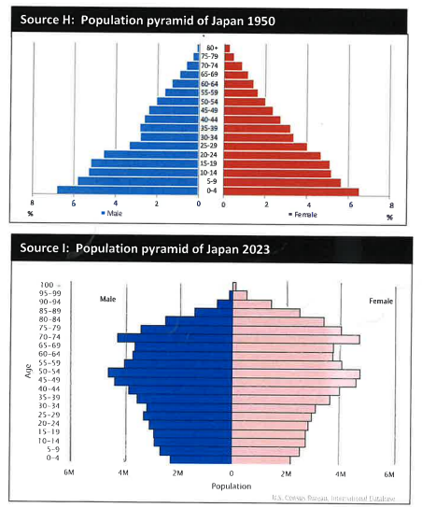

(a) How many females were there in the 70 -74 cohort in Japan in 2023? _______________ (1 mark)
(b) Why were there fewer males aged between 25 and 39 in Japan in 1950? ______________________________________________________________(1 mark)
(c) Describe the different structures of the population in Japan in 1950 and 2023. _______________________________________________________________________________________________________________________________________________________________________________________________________________________________________________________________________________________________________________________________________________________________________________________________________________________________________________ (3 marks

Question 17: Refer to Source J and use your own knowledge to answer Questions 17(a) and 17(b)

SECTION 2: SHORT ANSWER (20 marks)

Name:
Set:
Teacher:
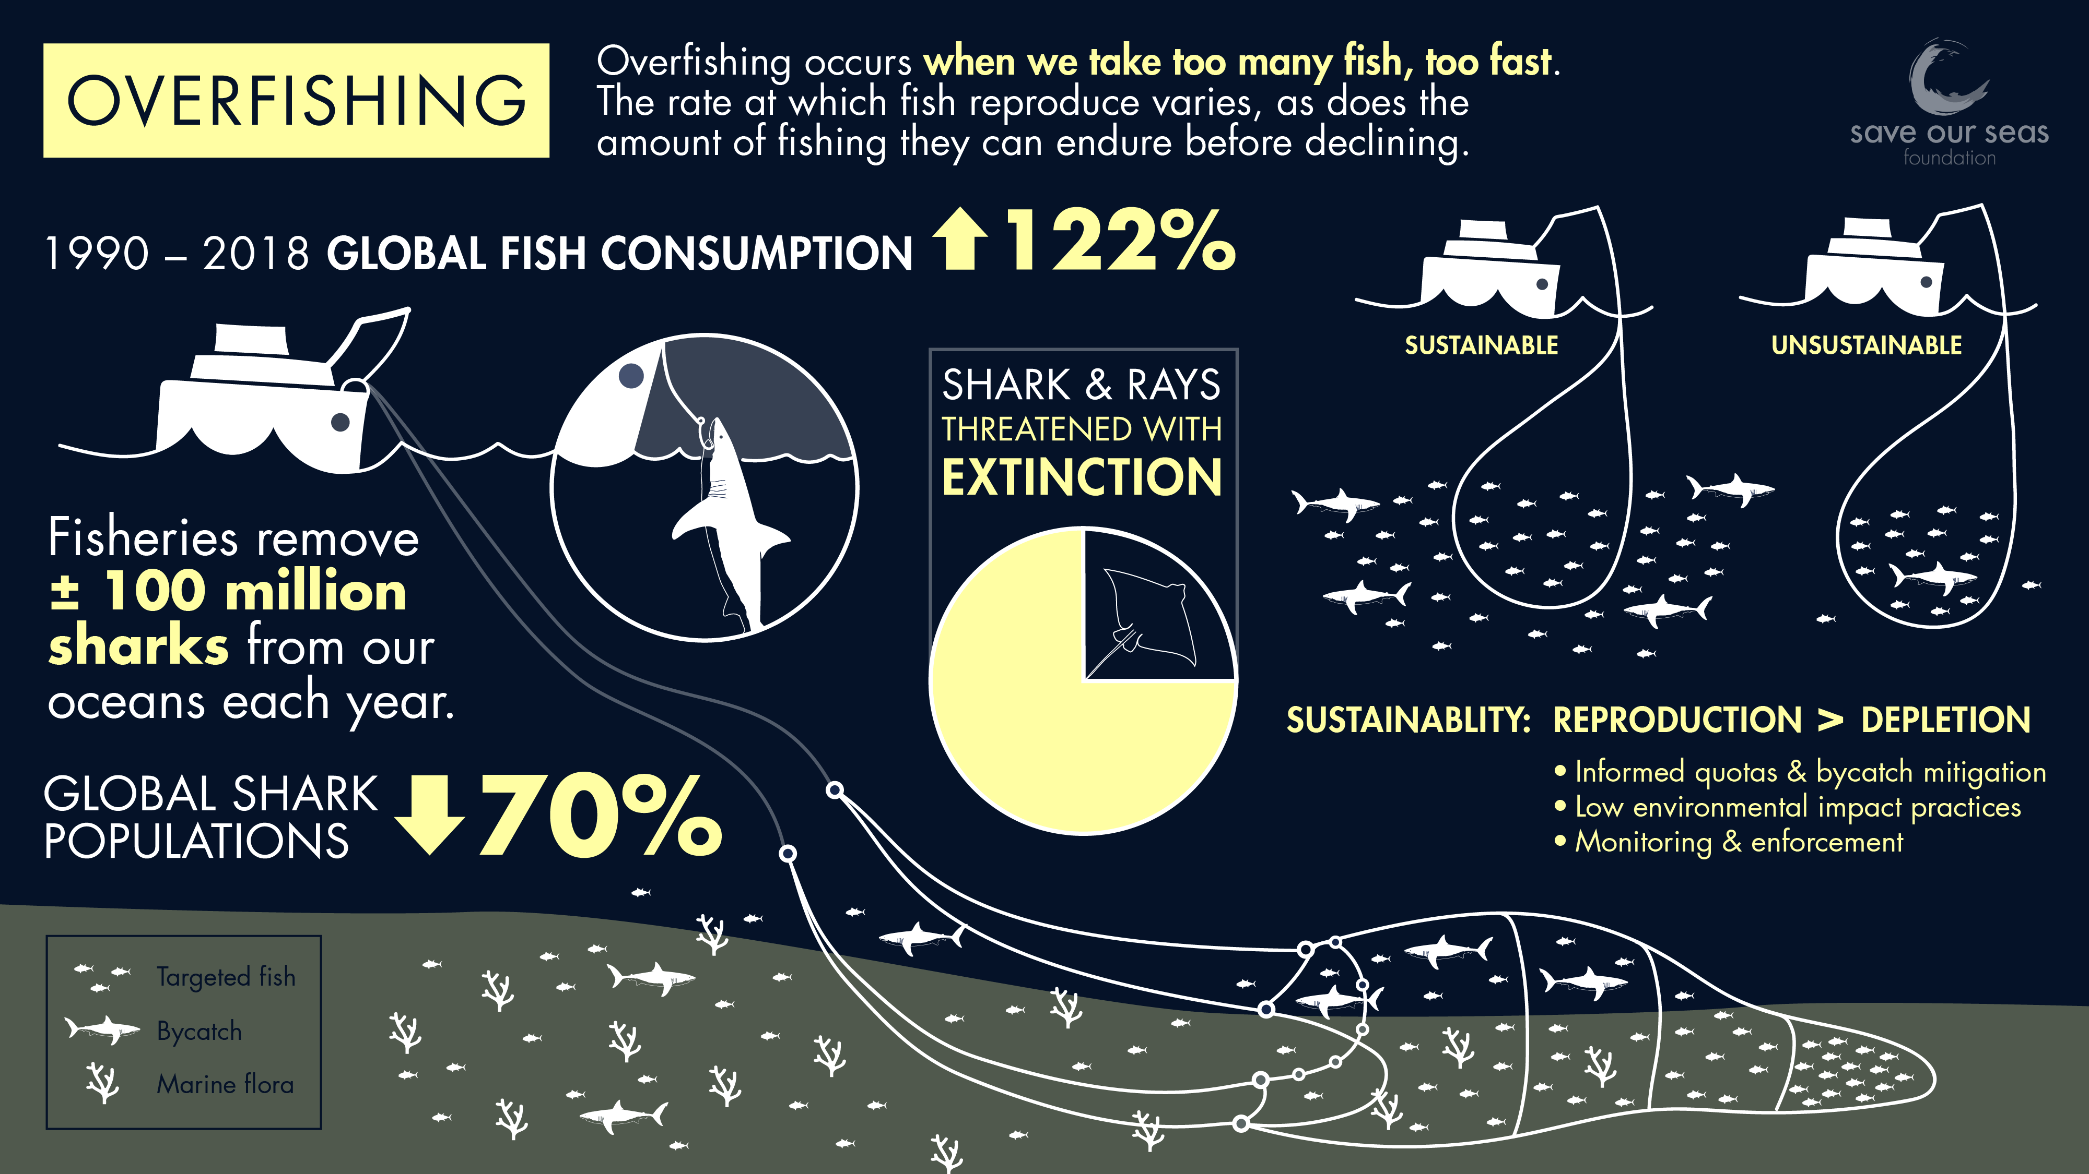
Source J Population pyramid of Japan 2023

Question 17(a): Demonstrate the impacts of humans on the world’s oceans. __________________________________________________________________________________________________________________________________________________________________________________________________________________________________________________________________________________________________________________________________________________________________________________________________________________________________________________________________________________________________________________________________________________________________________________________________________________________________________________________________________________________________________________________________________________________________________________________________________________________________________________________________________________________________________________________________________________________________________________________________________________________________________________________________________________________________________________________________________________________________________ (6 marks)
Question 17 (b): Account for the extent of overfishing. ______________________________________________
_______________________________________________________________________________________________
__________________________________________________________________________________________________________________________________________________________________________________________________________________________________________________________________________________________________________________________________________________________________________________________________________________________________________________________________________________________________________________________________ (4 marks)

Question 18: Refer to Source K and use your own knowledge to answer the following question
Source K Population pyramid of Japan 2023

Demonstrate how different environmental worldviews have shaped forest management.
___________________________________________________________________________________________________________________________________________________________________________________________________________________________________________________________________________________________________________________________________________________________________________________________________________________________________________________________________________________________________________________________________________________________________________________________________________________________________________________________________________________________________________________________________________________________________________________________________________________________________________________________________________________________________________________________________________________________________________________________________________________________________________________________________________________________________________________________________________________________________________________________________________________________________________________________________________________________________________________________________________________________________________________________________________________________________________________________________________________________________________________________________________________________________________________________________________________________________________________________________________________________________________________________________________________________________________________________________________________________________________________________________________________________________________________________________________________________________________________________________________________________________________________________________________________________________________________________________________________________________________________________________________________________________________________________________________________________________________________________________________________________________________________________________________________________________ (10 marks)
Name:
Set:
Teacher:

SECTION 3: EXTENDED RESPONSE (20 marks)

Question 19: Refer to Sources L and M and use your own knowledge to answer the following question.
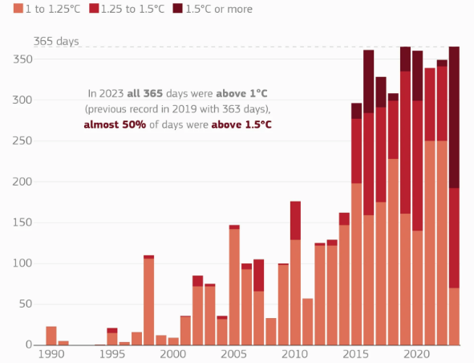

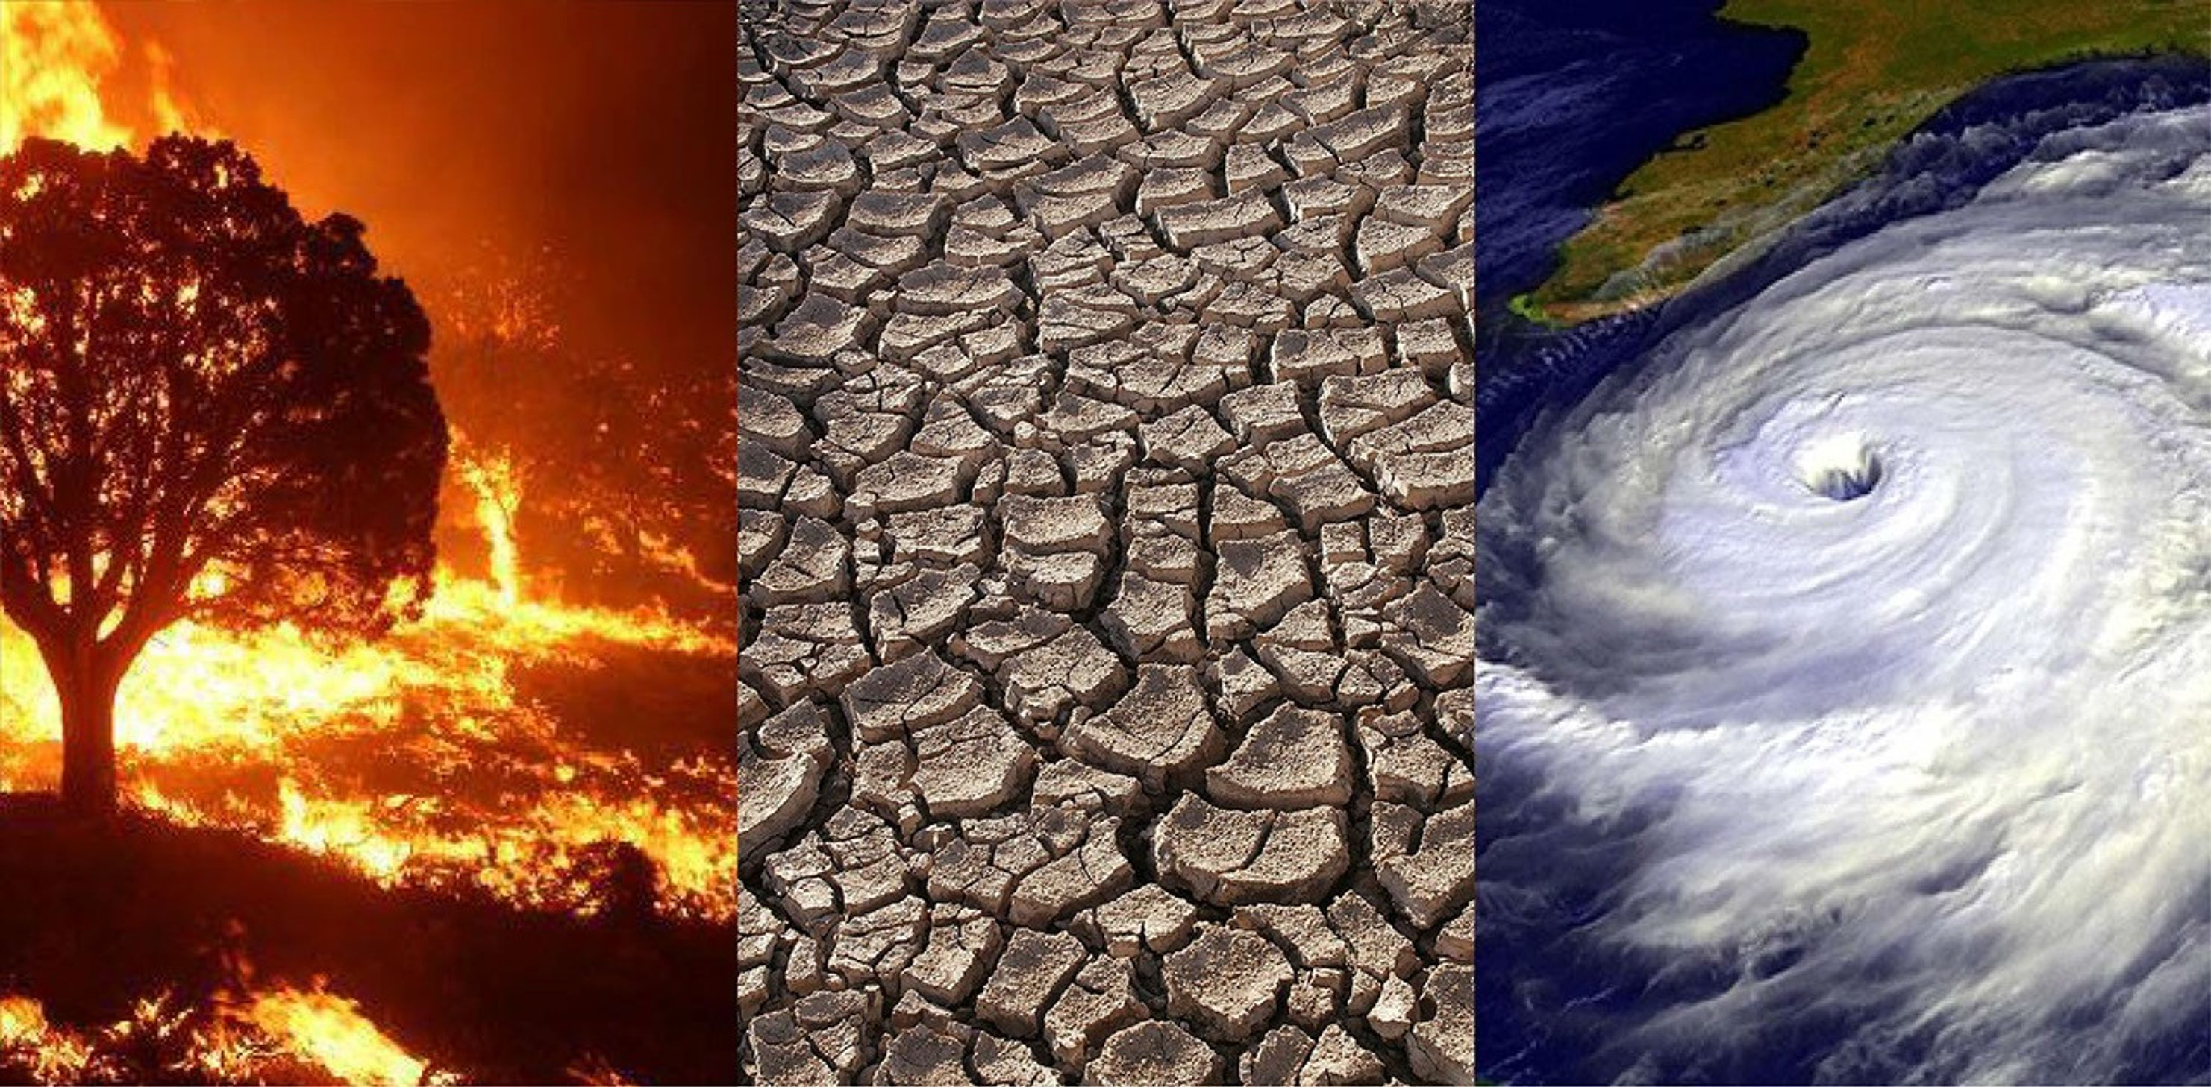

Source L Population pyramid of Japan 2023

Source M

Explain why global warming is occurring and outline the impacts of climate change.
________________________________________________________________________________________________________________________________________________________________________________________________________________________________________________________________________________________________________________________________________________________________________________________________________________________________________________________________________________________________________________________________________________________________________________________________________________________________________________________________________________________________________________________________________________________________________________________________________________________________________________________________________________________________________________________________________________________________________________________________________________________________________________________________________________________________________________________________________________________________________________________________________________________________________________________________________________________________________________________________________________________________________________________________________________________________________________________________________________________________________________________________________________________________________________________________________________________________________________________________________________________________________________________________________________________________________________________________________________________________________________________________________________________________________________________________________________________________________________________________________________________________________________________________________________________________________________________________________________________________________________________________________________________________________________________________________________________________________________________________________________________________________________________________________________________________________________________________________________________________________________________________________________________________________________________________________________________________________________________________________________________________________________________________________________________________________________________________________________________________________________________________________________________________________________________________________________________________________________________________________________________________________________________________________________________________________________________________________________________________________________________________________________________________________________________________________________________________________________________________________________________________________________________________________________________________________________________________________________________________________________________________________________________________________________________________________________________________________________________________________________________________________________________________________________________________________________________________________________________________________________________________________________________________________________________________________________________________________________________________________________________________________________________________________________________________________________________________________________________________________________________________________________________________________________________________________________________________________________________________________________________________________________________________________________________________________________________________________________________________________________________________________________________________________________________________________________________________________________________________________________________________________________________________________________________________________________________________________________________________________________________________________________________________________________________________________________________________________________
_________________________________________________________________________________ (20 marks)

